
User Guide

Introduction
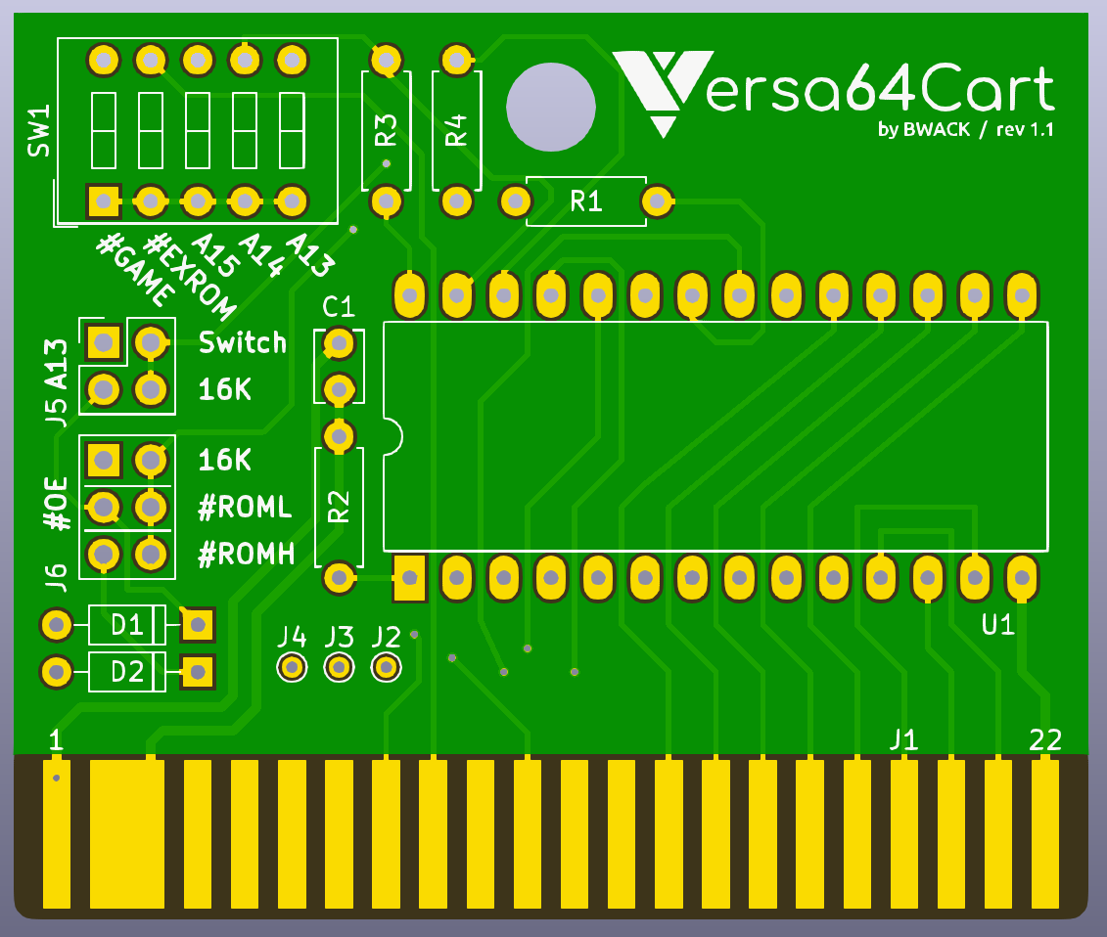
Versa64Cart is designed to be a modern easy-to-use cartridge development board for Commodore 64 and Commodore 128 hobbyists and hackers. The versatile design of the PCB allows for flexible implementation of various cartridge types. Whether it’s a simple cartridge backup of an 8k game or a
switchable multi-program diagnostic cartridge, Vers64Cart has you covered.

Overview

- Supported EPROMS:
27C64 (8k), 27C128 (16k), 27C256 (32k), 27C512 (64k)
- Ability to access multiple program images by using optional on-board DIP switches(*)
- Rapid low-cost production of clean, single image cartridges via simple solder pad bridging option
- PCB designed to fit inside any standard C64 cartridge shell, including centre post versions
- Rounded corners to allow for easier cartridge insertion and reduced wear to PCB

(*) CAUTION: Only make DIP switch changes when computer is power off. Never change DIP switch settings while cartridge is inserted and computer is powered on.

Jumpers and dipswitches
Bank control

The dipswitch controls EPROM_ A13
in 8k mode.
The computer controls EPROM_A13
in 16k mode
#ROML & #ROMH are mixed
by D1 and D2 in 16k mode
because two chipselects
has to become one
ROMs with start address $8000
ROMs with start address $E000
test points: CPU A15, A14, A13

Technical note: The Versa64Cart makes it possible to run 2x8k (16k) ROM games on a single 16k EPROM device. Two chipselects has to become one, and the two 8k images has to be banked with A13.

Banking is easy, we let the computer control EPROM_A13. A jumper is put on J5:16k. The jumper now disconnects dipswitch A13 and reconnects #ROML to EPROM_A13. We have banking! The two chipselects are #ROMH and #ROML and are mixed with D1 and D2. A jumper on J6:16k routes the mixed signal to the EPROM_#OE.

Instead of #ROML on EPROM_A13 we could have used CPU_A13. It would have a better timing, because #ROML is a product of A13 from the PLA, but would it work in ultimax mode? In ultimax mode the two 8k banks are not placed adjacent ($8000-9FFF and $E000-$FFFF).

Setting #GAME and #EXROM
Mapping the EPROM into memory is done with the #EXROM and #GAME jumpers. There are 4 modes:

8k: #EXROM=0, #GAME=1 : start $8000-$9FFF #ROML
8k ultimax: #EXROM=1, #GAME=0 : start $E000-$FFFF #ROMH
16k: #EXROM=0, #GAME=0 : start $8000-$9FFF (#ROML) + $A000-$BFFF (#ROMH)
16k ultimax: #EXROM=1, #GAME=0 : start $8000-$9FFF (#ROML) + $E000-$FFFF (#ROMH)

You can find the mode of a .CRT file using WinVICE's cartconv.exe.

C:\WinVICE-2.4-x86>cartconv -f Wizard_of_Wor.crt
CRT Version: 1.0
Name: Wizard of Wor
Hardware ID: 0 (Generic Cartridge)
Mode: exrom: 0 game: 0 (16k Game)

offset sig type bank start size chunklen
$000040 CHIP ROM #000 $8000 $4000 $4010
Finding the mode for Wizard of Wor in a CRT file.

#EXROM and #GAME are routed to the PLA and the PLA is the address decoder inside the C64. The PLA controls and drives the ROML and ROMH signals used to put the EPROM onto the data bus.

Converting .CRT to .BIN
The EPROM must be programmed with a binary file. Use WinVICE's cartconv.exe tool to convert the .CRT file.

C:\WinVICE-2.4-x86>cartconv -i Wizard_of_Wor.crt -o wizardofwor.bin
Input file : Wizard_of_Wor.crt
Output file : wizardofwor.bin
Conversion from Generic Cartridge .crt to binary format successful.
Converting CRT to BIN for burning to EPROM.

Solder Jumpers
You don't need to attach jumpers and dipswitches if you just want a single game or a dead test cart. You can use solder jumpers instead.
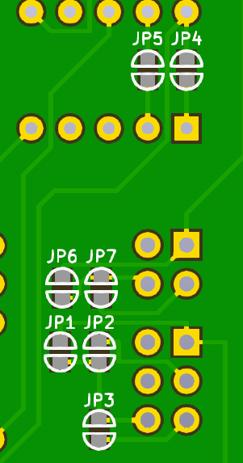
solder jumper settings | #EXROM | #GAME | switch | 16K | 16K | #ROML | #ROMH
mode | JP5 | JP4 | JP6 | JP7 | JP1 | JP2 | JP3
8k | x |  | x |  |  | x
8k ultimax |  | x | x |  |  |  | x
16k | x | x |  | x | x
16k ultimax |  | x |  | x | x

A Multi-Cart Example
An example with 16k + 8k + 8k ROM images on a 27C256 (32k) EPROM.

Jumpan Junior: 16k, #EXROM=0, #GAME=0
Dead Test: 8k ultimax, #EXROM=1, #GAME=0, start=$E000 (#ROMH)
Jupiter Lander: 8k, #EXROM=0, #GAME=1, start $8000 (#ROML)

memory area | ROM image | dipswitch & jumpers
$0000-$1FFF | Jumpan Junior | ↑↑x↑x, J5:16k, J6:16k
$2000-$3FFF | Jumpan Junior | ↑↑x↑x, J5:16k, J6:16k
$4000-$5FFF | Dead Test | ↓↑x↓↑, J5:Switch, J6:#ROMH
$6000-$7FFF | Jupiter Lander | ↓↑x↓↓, J5:Switch, J6:#ROML

dipswitch positions: ↑=0V, ↓=5V, x=don't care

now you should write down the settings because you will forget them.

Bill of Materials (BOM)

Appendix

Board Layout
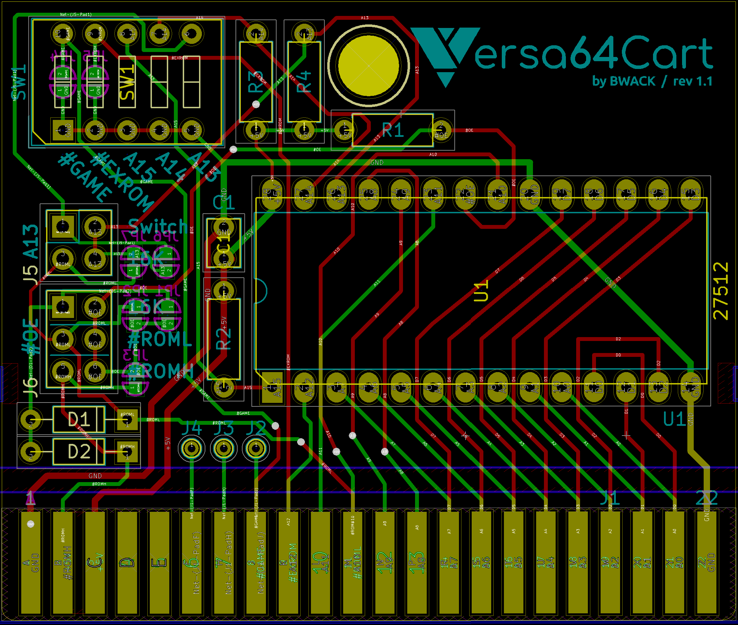
A screen shot taken in KiCAD Pcbnew

